This new local Snort rule is wrote for pcap_a.pcap. Here is the content of new rule.

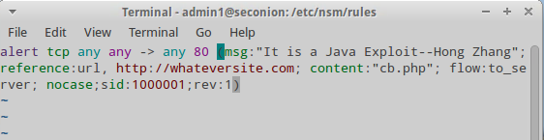

Next is the screenshot which shows the fired rule in Sguil.

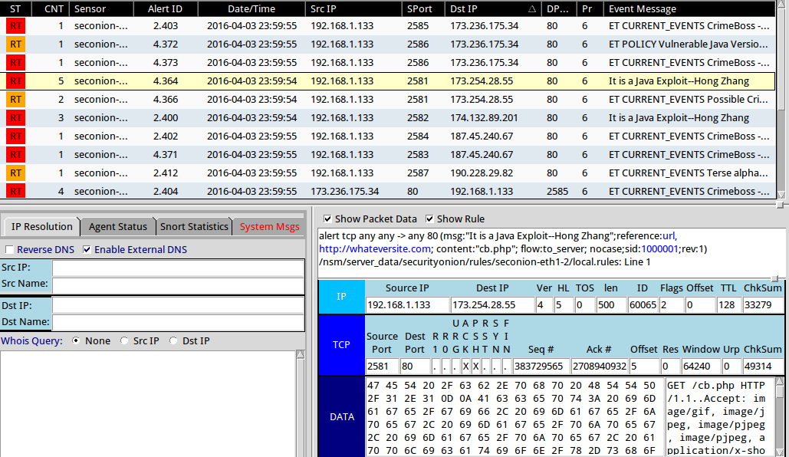

This following new local Snort rule is wrote for pcap_b.pcap. Here is the content of new rule.

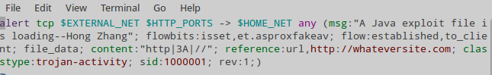

Next is the screenshot which shows the fired rule in Sguil.

